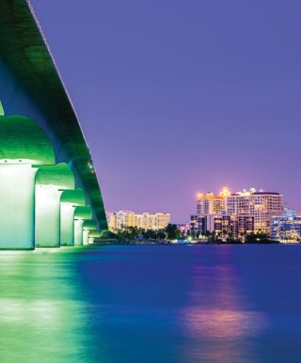
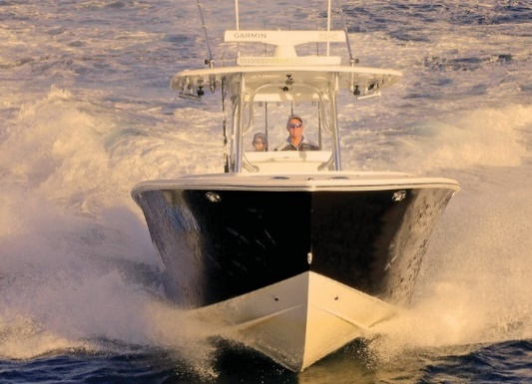
EXHIBITOR MANUAL

DOWNTOWN SARASOTA, FLORIDA

APRIL 19 - 21, 2024 SUNCOASTBOATSHOW.COM
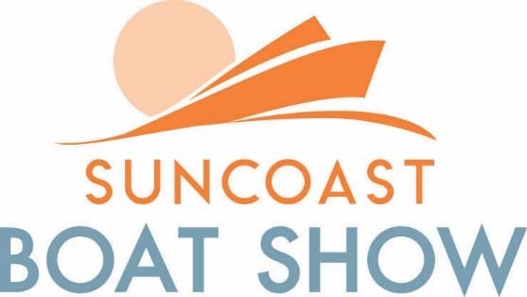

SHOW LOCATIONS AND SCHEDULE
SHOW LOCATIONS
Marina Jack, #2 Marina Plaza, Sarasota, FL 34236
Take I-75 to S.R. 780 west; exit 210 toward Sarasota/St. Armands/Mote Marine/Gulf Beaches. Merge onto Fruitville Road. Turn left onto Tamiami Trial/US 41. Continue to follow US-41. Turn right into Marina Plaza or see downtown parking garages in the area.
SHOW HOURS
Friday | April 19, 2024 | 10am – 6pm
Saturday | April 20, 2024 | 10am – 6pm
Sunday | April 21, 2024 | 10am – 5pm

ADDITIONAL SHOW INFORMATION VISIT: www.suncoastboatshow.com
SHOW SET-UP
Wednesday | April 17, 2024 | 8am – 3pm
Thursday | April 18, 2024 | 8am – 3pm
SHOW BREAKDOWN
Sunday | April 21, 2024 | 5:30pm – 9pm
Monday | April 22, 2024 | Booth Breakdown by 10am
Land & Water Breakdown |  | 8am – 12 noon

TICKETS AND CREDENTIALS
SHOW TICKETS
Show Days (Thursday-Sunday) | Ticket Price | Exhibitor Price | Regular Price
Adult 1-Day Ticket (16 & Over) | $19.00 | $11.50 | $18.00
Military & Active Duty | FREE
Children 15 & Under are Free

IMPORTANT:
- The credential deadline is April 15th, 2024. After this date, a late fee of $10.00 will be charged per credential. Additional credentials purchased over allotment will cost $11.00 each.
- Exhibitor guest credentials, good for all 3 days of the show, are available for purchase on the exhibitor EventsPass vendor portal for $34.00 each.
- Due to new safety standards, paper tickets are no longer issued and there is no Will Call on show site.
- Exhibitor credentials and tickets are primarily digital and distributed through EventsPass.
- All exhibitors will receive a welcome letter with a link to create a password & account for EventsPass. Once completed, credentials and tickets orders can be placed and sent out to the appropriate person.
- Tickets/credentials can be managed on the vendor dashboard as well, including changing or editing the registration details and resending the tickets.
- If you would like printed badges, you may request them at the Credentials office(s) on show site.

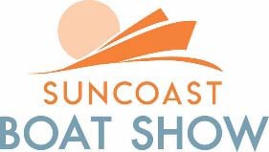

GENERAL INFORMATION

SHOW ENTRANCE
Admittance to the Show grounds will be permitted each morning at 8:00 a.m.

PARKING
Exhibitor parking will be available in the new city garage located one block from show site.
(Only vehicles NO small trailers will be allowed.)

SHOW OFFICE LOCATIONS
The Show office, Credential office, Convention Services office and Electric office trailer will be located on the Show grounds. The Show offices will be open Wednesday, April 17 from 12:00 Noon to 5:00 p.m., on Thursday, April 18 from 8:00 a.m. to 5:00 p.m. On Show days, the offices will be open Show hours.

SET-UP/BREAKDOWN
It is extremely important that the rules and schedules are carefully reviewed in this section. We will require your cooperation to insure a smooth set-up and timely presentation of the Show. The Set-up/Breakdown pass or your Exhibitor Credential must be worn during the Set-up/Breakdown period in order to gain admittance to the Show grounds. The Set-up/Breakdown pass is only valid during the Set-up/Breakdown dates and times. Starting on the first day of the Show, the Exhibitor Credential must be worn for admittance to the Show.

SECURITY DURING BREAKDOWN
There are security procedures and checks in place. However, it is difficult to control the rush of
Exhibitor and their personnel from removing materials from the Show. Many Exhibitors with small items take advantage of the Special Sunday Breakdown period on the day of Show closing. While this is hectic and may not be convenient for you, it is certainly an excellent way to prevent theft or damage to your items. If this Special Breakdown period is inconvenient, please take these simple steps that should prevent any problems.

_ Pack all exhibit materials at the close of the show
_ Group all small items together and cover your items with tarp(s)
_ Dismantle display cases and signs
_ Move all materials away from the aisles
_ Return the following day at your breakdown time to begin removal of your exhibit

CASH AND CARRY - SALES OF MERCHANDISE
This form MUST be completely filled out and returned to Informa Markets by April 1, 2024. A form is provided in the exhibitor kit for those who do not have a Florida State Sales Tax Certificate Number. Please place the order early as it takes 7-10 working days for the State to process your request.
Please Note sales tax is 7%

LAUNCHING FACILITY
There is a launching ramp for small boats located at Ken Thompson Park. Launching and commissioning of larger boats (sail or power up to 50’ in length and 15’ of beam) shipped in by truck may be arranged through the following facility:

Marine Max Craig Hineshaw
1601 Ken Thompson Parkway Sarasota, Fl 34236
(941) 388-4411

INSURANCE REQUIREMENTS
Each Exhibitor is required by contract to carry $1,000,000.00 of Liability Insurance to cover the exhibit space(s) occupied in the Show. Complete information can be found on the Insurance Order. For further information, please call 954/764-7642 or 800/940-7642.

INCLEMENT WEATHER
We anticipate having nice weather. However, the weather cannot be controlled. In the case of prolonged inclement weather, the tent areas may become saturated and/or leak. Please be prepared with plastic tarps or other protective means to ensure a successful Show.

SHOW MANAGEMENT CONVENTION SERVICES

FREIGHT SHIPMENTS
The Suncoast Boat Show is not required to accept any shipments for your exhibits. Show Management Convention Services will be happy to accept and store your shipments for a moderate charge.

EXHIBIT CRATES
Please contact Show Management Convention Services for this service. If your exhibit freight and delivery is handled by Show Management Convention Services, they will arrange for the pick-up, storage and return of your empty crate(s). Otherwise, you must contract and pay for this service as a separate entity.

SHOW MANAGEMENT ELECTRIC
Power is not included in the space cost. Those requiring power for booth or land space, please fill out the “Show Management Electric Service Order Form”. Please complete the form and return it along with full payment, prior to the deadline. Should you have any questions, please call Show Management Electric at (954) 327-1401.
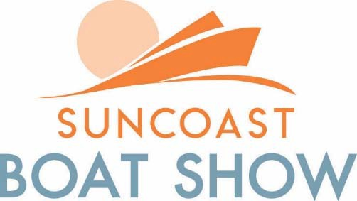
2024
AREA CONVENIENCES
boatshows@onpeak.com | Donnelly’s Printing | Courtesy Cab
(855) 742-9183 Toll-free | 1262 North Palm Avenue | 3718 Dover Drive
 | Sarasota, FL 34236 | Sarasota, FL 34236
 | PH: 941/365-3014 | PH: 941/954-1970

AIRPORT SERVICES:

Sarasota Bradenton International Airport
6000 Airport Circle
Sarasota, FL 34230
PH: 941/359-2770

BANKING:

Bank One Wachovia
240 North Washington Boulevard 300 Madison Drive STE 240 Sarasota, FL 34236
Sarasota, FL 34236 PH: 941/361-5849 PH: 941/954-4432

HOSPITAL - Emergencies Dial 911

Sarasota Memorial Hospital 1700 South Tamiami Trail Sarasota, FL 34239
PH: 941/917-9000

AIRLINE/CAR RENTAL DISCOUNTS:

Southwest | Delta Air Lines | United Airlines | Hertz
Discount / Promotion code: TBD | Discount / Promotion code: TBD | Discount / Promotion code: TBD | Discount/CDP/Club Code: TBD
To book a flight with your promotion code, access swabiz.com and enter your Company ID Number in the Company ID Number box. | Please click here to book your flights! | To book a flight with your promotion code, access United and enter your promotion code in the Promotions and Certificates box. When searching for flights click on “United or United Express Flights” radial dial. | To book a car rental with your promotion code, access Hertz and enter the code under Discount/CDP/Club Code in the Discount Code box to receive a 20% discount on your car rental.

- SHOW MANAGEMENT

RULES AND REGULATIONS

The "SUNCOAST BOAT SHOW” is produced and managed by Informa Markets. All decisions regarding space assignments, nature and style of exhibit, floor management before, during and after the Show hours shall be made by Informa Markets. Informa Markets shall have full power in the interpretation and enforcement of these rules and regulations and the power to make amendments thereto and such further rules and regulations as they shall consider necessary for the proper conduct of the Show.

CHARACTER OF EXHIBITS
Only those products or services directly related to the design, construction and use on recreational boating and the marine industry will be eligible for display and only with the written approval of Informa Markets. Exhibitors shall display their products and conduct their business only within their assigned space. No placard, stickers or other signs relating to non-exhibiting firms will be allowed in individual exhibits or anywhere else in the Show. Lotteries, drawings, guessing games, or prize contests of any kind sponsored by individual Exhibitors are subject to Informa Markets prior written approval. No horns or alarms, whether part of the equipment of boats or separate exhibits, will be permitted to be operated. Flashing signs or lights and revolving flasher lights are prohibited. No amplifiers or loudspeakers may be operated in individual exhibits. Self–contained, automatic motion picture equipment, slide projectors or other audio/visual equipment may be operated in individual exhibits only with the understanding and signed approval of Informa Markets. No television receivers will be permitted except those designed for marine use and exhibited by the manufacturer. No advertising or printed matter, which, in the opinion of Informa Markets, is undignified or otherwise objectionable, shall be distributed. Exhibitors have the right to distribute catalogs and other printed matter, approved by Informa Markets, from the space occupied by them, but in no other way. Informa Markets reserves the right to decline or prohibit any exhibit or proposed exhibit or to prohibit any activity at an exhibit which, in its opinion, is not suitable for the SUNCOAST BOAT SHOW. This reservation concerns persons, things, decorations, conduct, printed matter, souvenirs, catalogs and all other things which affect the character of the Show.

PAYMENT FOR SPACE
Application for space must be submitted on the official contract application form and must be accompanied by the deposit specified the rein. After allocation of space, each applicant must execute a signed contract for space with Yachting Promotions, Inc. and make additional payments as provided in said contract. NO GOODS WILL BE PERMITTED TO BE PLACED IN THE EXHIBITION SPACE UNTIL ALL PAYMENTS FOR SPACE RENTAL HAVE BEEN MADE.

SUBLEASING
Exhibitors may not sublease, assign or apportion their space. No more than one firm may exhibit in a single space without the written permission of Informa Markets. No goods or products other than those manufactured or sold in the regular course of business shall be displayed by Exhibitor.

SALE OF MERCHANDISE
The sale of certain goods for delivery during the Show under a special "Cash and Carry" program will be permitted. This program will be controlled with strict rules including minimum inventory and periodic inspections of exhibits by Informa Markets. Boats and other large items will not be included in this program. Exhibitors wishing to participate must present complete information regarding their proposed exhibit.

BOOTH EXHIBITS
Booth areas will contain an 8 ft. high cloth backwall drape and 3 ft. high cloth side dividers. All Booth exhibits shall be limited to an 8 ft. backwall with no portion of the display extending out from the backwall more than 1/3 of the total space depth at a height exceeding 8 ft. All exhibits shall be erected so as not to obstruct the view of neighboring exhibits. Carpet is not included in your booth price, however, it is available.

LAND & BULK EXHIBITS
Boats and trailers must be within the boundaries of their space. Boats or engines that are unloaded must be placed with the proper equipment to assure the safety of the public and your company. Informa Markets shall have no liability regarding this procedure. Individual Electric service is not provided in the Land exhibit area however, service is available at the Exhibitor's expense.

IN-WATER EXHIBITS
Electric service is available at each slip as shown on the enclosed Show Management Electrical Service Order Form. Should your boat(s) require special service not identified on the form, please call our office. It is essential that you fill out the form in this manual and return it along with the deposit required before the deadline. Orders received after the deadline will be charged at the standard rate.
Boarding devices, signs and other exhibit materials placed on the floating docks must not protrude more than 24 inches from the edge of the dock. Exhibitors should keep in mind that during peak hours the docks are very crowded and materials placed on them may be a safety hazard to the Show visitors, other Exhibitors and yourself. If you want to install a sign or any exhibit material (i.e. steps, etc. which requires drilling holes or nailing to fasten to the wood decking, the "Exhibit Installation Form" must be filled out and returned along with the deposit required.

LIGHT AND POWER
Sufficient lighting will be provided for general illumination of the entire Show area. Exhibitors requiring special lighting or an electric outlet should see the Show Management Electrical Service Order Form.

CARE AND STAFFING OF EXHIBITS
Informa Markets will arrange for cleaning docks, tent and general Show area. Exhibitors must, at their own expense, keep their exhibit area clean, boats washed, and total exhibit in a first class condition. No pets will be allowed on the Show grounds at any time. Each Exhibitor is responsible for the space occupied and shall make, at its sole cost and expense, all repairs thereto, made necessary by the negligence of the Exhibitor, its licensees, employees, agents and visitors. ALL EXHIBITS MUST BE ADEQUATELY AND PROPERLY STAFFED AT ALL TIMES DURING SHOW HOURS. EXHIBITS MUST NOT BE LEFT UNATTENDED DURING SHOW HOURS.

INSTALLATION AND REMOVAL OF EXHIBITS
All exhibits must be removed in accordance with the breakdown schedule. Any exhibit or boat not removed on a timely basis will be removed and stored at the Exhibitor's expense. The set-up and breakdown schedules as identified in this Exhibitor's Manual must be strictly adhered to for the safety and convenience of all Exhibitors and the timely presentation of the Show. Please pay particular attention to the schedule as it relates to your exhibit. Installation and removal of exhibits shall be made at the expense of the Exhibitor. Forklift/Crane service will be available upon request in advance. Requests for special services should be made in writing at least fifteen
(15) days prior to the Show opening. A service desk will be set up during the installation period to receive orders for any special services required to coordinate the activities of all service personnel. A Set-up Official will be on hand to assist Exhibitors during the installation period.

EXHIBITOR CREDENTIALS
Credentials will be issued to working exhibit personnel upon submitting an online request by the EXHIBIT REPRESENTATIVE. There is a limit to the number of credentials permitted to any one Exhibitor. Credentials will not be released until all space payments have been made. Credentials must be left in the Credential Office.

DISPLAYS IN PARKING AREAS
Boats, trailers and other production displays are not permitted in the parking areas during the Show hours.

ORDINANCE COMPLIANCE
All Electrical, Fire and Health Department regulations, and all City, State, and Federal laws shall be complied with by all Exhibitors.

HOURS OF EXHIBITION
ABSOLUTELY NO DISMANTLING OF ANY PORTION OF ANY EXHIBIT WILL BE ALLOWED PRIOR TO 30 MINUTES
AFTER SHOW CLOSING. Informa Exhibitions reserves the right to alter the Show hours without advance notice to Exhibitors and to require immediate evacuation of the Show site including people and/or exhibits in the event of a hurricane, tornado, storm or other "Acts of God" or government interference, without liability to Exhibitors.

INDEMNITY INSURANCE
Neither Informa Markets, nor the Marine Industries Association, nor their representatives or agents (“indemnified parties”) shall be liable or responsible for any injury to Exhibitors, or their employees, or guests, or visitors while within the confines of the Exhibit Space or while on any boat (or boarding device thereto) which the Exhibitor has in the water at the Boat Show; nor shall they be liable for the loss or damage to any goods from any cause whatsoever while the same are in transit to or from the Show, or while they are located in the Exhibit Space. Exhibitor hereby indemnifies and holds the Indemnified Parties harmless from any and all such claims, liabilities, damages and expenses (including attorneys’ fees arising from the foregoing injuries, losses or damages. The indemnity provisions contained herein shall survive the expiration or earlier termination of this Agreement. Exhibitor shall be responsible at its expense for obtaining commercial general liability insurance with minimum limits of $1,000,000.00 per occurrence and shall provide a certificate of insurance not less than 45 days prior to show opening naming Yachting Promotions, Inc. as an additional insured.

SUNCOAST BOAT SHOW BOOTH REGULATIONS

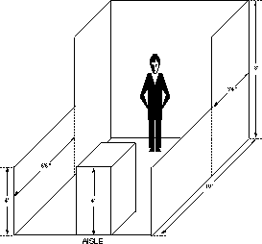
STANDARD BOOTH:
AISLE
HEIGHT: Exhibit fixtures, components and identification signs will be permitted to a maximum height of 8 ft. Outside canopies are 8 feet in height.
INTENT: If a portion of an exhibit booth extends above 8 ft. high, the exhibit booth background will detract from the overall impact of the exhibit directly behind that booth regardless of how the rear of the offending exhibit is finished.
DEPTH: Booth areas in the tents contain an 8 ft. high cloth backwall and 3 ft. high cloth side dividers with no portion of the sides of the display to extend out from the backwall line more than 1/3 of the total space depth at a height not to exceed 8 ft.
All exhibits shall be erected so as not to obstruct the view of neighboring exhibits. Special conditions may apply. Please call for further information.
INTENT: Each Exhibitor is entitled to a reasonable sightline from the aisle regardless of the size of the exhibit. Exhibitors with larger space (30 linear feet or more) should also be able to effectively use as much of the total floor space as possible as long as they do not interfere with the rights of others. This limitation on display fixtures over 3 ft. and within 10 linear feet of a neighboring exhibit is intended to accomplish both of these aims.

IMPORTANT: Space dimensions shown on the floor plan are from the cen- ter line of the booth equipment, such as side rails and/or back drape
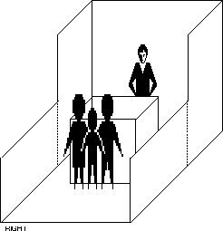
Exhibit structures must be constructed to allow sufficient tolerance on each side for this equipment and for utility service at rear of booth.

CORRECT

BOOTH DEMONSTRATIONS:
REGULATION: Demonstration areas must be organized within the Exhibitor's space so as not to interfere with any traffic aisle and sampling or demonstration tables must be placed at a minimum of 2 1/2 ft. from the aisle line. Should spectators or samplers interfere with the normal traffic flow in the aisle or overflow into neighboring exhibits, Yachting Promotions, Inc. will have no alternative but to request that the presentation or sampling be eliminated.
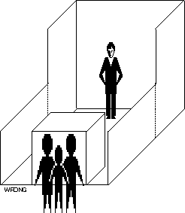
INTENT: The aisles are the property of the entire Show and each Exhibitor has the responsibility to assure proper flow of traffic through the entire Show. When large crowds gather to watch a demonstration or for sampling and interfere with the flow of traffic down aisles or create excessive crowds in neighboring booths, it is an infringement on the rights of other Exhibitors. Aisles must not be obstructed at any time.

INCORRECT
SOUND: No amplifiers or loud–speakers may be operated in individual exhibits. Self–contained, automatic motion picture equipment, slide projectors or other audio/visual equipment may be operated in individual exhibits only with the understanding and signed approval of Yachting Promo- tions, Inc. No television receivers will be permitted except those designed for marine use and exhibited by the manufacturer. Yachting Promotions, Inc. reserves the right to determine at what point sound
constitutes interference with others and must be discontinued.
SAFETY PRECAUTIONS: All product demonstrations involving any moving and potentially hazardous machines, displays or parts, must have hazard barriers to prevent accidental injury to spectators. Demonstrations must always be supervised by Exhibit personnel who can stop the demonstration in the event of an emergency and all demonstrations involving potentially hazardous by–products, such as dust, fumes, sparks or flames, etc., must be approved in writing by Yachting Promotions, Inc. thirty (30) days prior to the Show opening.

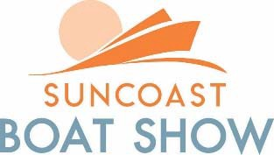

FLORIDA TAXATION of BOAT SHOW EXHIBITORS
2024 SALES and USE TAX

GENERAL RULES

A seven percent sales tax is imposed on every “retail sale” of tangible personal property within Sarasota, Florida. Some counties impose additional local optional or discretionary surtaxes: 7% etc. ”Retail sales” include sales that take place in Florida and “mail order sales” by companies who are required to register as dealers under Florida’s sales tax law.

A “dealer” is any person who, among other activities, does the following:

- sells tangible personal property;
- solicits sales of tangible personal property;
- leases tangible personal property;
- sells, provides, or performs a taxable service; or
- imports tangible personal property for use, consumption, distribution, or storage.

Sales tax is not imposed on “sales for resale,” that is, sales to persons or companies who themselves are registered as Florida sales tax dealers and purchase the item for resale. A dealer who makes a “sale for resale” to another dealer must obtain and keep on file a Florida resale certificate from the purchaser to document the exempt status of the sale. If a company makes sales in Florida, including sales at a boat show, it must register as a dealer with the Florida Department of Revenue (DOR) and must collect sales tax on its sales or obtain and keep on file Florida resale certificates. As long as it is required to be registered as a dealer with the DOR, a company must collect sales tax on Florida sales and must submit monthly sales tax returns and remittances to DOR. If an article of tangible personal property is brought into Florida and is subject to use tax, the DOR will allow credit for sales or use taxes paid to another state, U.S. territory or the District of Columbia. Credit cannot be given for taxes paid to another country.
Purchasers who cannot show that Florida’s or another state’s sales tax has been paid (at a rate equal to or greater than Florida’s rate) upon the purchase of tangible personal property must pay use tax on the cost of the item.

EXAMPLES
Please Note: The Following examples are bases upon the premise that an out-of-state exhibitor’s only presence in Florida is attendance at no more than a few Florida boat shows. Any additional presence or activities conducted by out-of-state exhibitor within Florida may result in different answers to some of the examples.

Sales at Boat Show for Immediate Delivery

Example 1: Exhibitor Who Makes Only Retail Sales at Boat Show
An out-of-state exhibitor attends a Florida boat show. Boats or accessories are sold or delivered at the show only to retail customers. This exhibitor must register with the DOR as a dealer, collect the sales tax on all retail sales made at the show, and file monthly sales tax returns.

Example 2: Exhibitor Who Makes Only Wholesale Sales at Boat Show
An out-of-state exhibitor attends a Florida boat show. Boat or accessories are sold or delivered at the show only at wholesale to persons who are registered as sales tax dealers. If the exhibitor has signed an Exhibitor’s Agreement, which prohibits it from making retail sales but allows it to make wholesale sales, the exhibitor is not required to register with the DOR as a dealer, or collect tax on the sales, because only sales for resale are made. If the exhibitor has not signed an Exhibitor’s Agreement, the exhibitor must register with the DOR as a dealer. In either case, the exhibitor must obtain and keep on file Florida resale certificates from the purchaser to document the exempt status of the sales.

Example 3: Exhibitor Who Makes Both Retail and Wholesale Sales at Boat Show
An out-of-state exhibitor attends a Florida boat show. Boats or accessories are sold or delivered at the show both on a retail and wholesale basis. This exhibitor must register with the DOR as a dealer, collect the sales tax on all retail sales made at the show, and file monthly sales tax returns remitting the tax on such sales. Florida resale certificates must be obtained and kept on file from all wholesale purchasers, to document the exempt status of those sales.

Sales at Boat Show for Future Delivery Outside Florida

Example 4: Exhibitor Who Takes Order at Show for Future Delivery Outside Florida
An out-of-state exhibitor attends a Florida boat show. Orders are taken for boats or accessories at the show for future delivery to an address outside of Florida. These orders are subject to acceptance or rejection at the exhibitor’s home office following an appropriate credit check, etc. The exhibitor is not required to collect the sales tax on these transactions, whether or not the exhibitor is registered as a Florida dealer.

Sales at Boat Show for Future Delivery In Florida

Example 5: Exhibitor Who Takes Orders at Show for Future Delivery in Florida But Does Not Receive Full Payment at the Show
An out-of-state exhibitor attends a Florida boat show. Orders are taken for boats and accessories at the show for future delivery to a Florida address.

Case A: The Purchaser makes a deposit or partial payment at the boat show. The balance of the purchase is paid to the exhibitor after the exhibitor returns to the home office, for example, by wire transfer or by check mailed to that office. The exhibitor is not required to collect the sales tax. This transaction is completed outside Florida and is not treated as a Florida sale. The purchaser is required to pay a use tax upon receipt of the boat or accessories.

Case B: The purchaser pays for the goods by credit card. The credit card transaction is processed for authorization at the exhibitor’s home office after the conclusion of the show. The exhibitor is not required to collect the sales tax. This transaction is completed outside Florida and is not treated as a Florida sale. The purchaser is required to pay a use tax upon receipt of the boat or accessories.

Example 6: Exhibitor Who Takes Orders for Future Delivery in Florida But Does Receive Full Payment at the Show
An out-of-state exhibitor attends a Florida boat show. Orders are taken for boats or accessories at the show for future delivery to a Florida address. The purchaser completes payment for the goods in Florida, either by cash, a check for the full purchase price, or a credit
card for which authorization is obtained during the show. This exhibitor is not required to collect the sales tax on these transactions, even if the exhibitor is registered as a dealer. The purchaser is required to pay a use tax upon receipt of the boat or accessories.

Sales After the Show to Florida Residents

Example 7: Exhibitor Receives Post-Show Telephone or Mail Orders from Florida
An out-of-state exhibitor attends a Florida boat show. After the exhibitor returns home, orders are received by telephone and mail for boats or accessories to be shipped to Florida.
This exhibitor is not required to collect the sales tax on these transactions, even if the exhibitor registered as a dealer. The purchaser is required to pay a use tax upon receipt of the boats or accessories.

Example 8: A Florida Resident Visits the Manufacturer’s Plant after a Show And Places an Order for Delivery into Florida
An out-of-state exhibitor attends a Florida boat show. After the exhibitor returns home, a Florida resident visits the plant and places an order for delivery into Florida. The exhibitor is not required to collect the sales tax on this transaction, even if the exhibitor has been required to register as a Florida dealer because of the boat show activities. The seller must document that the purchaser was physically present at the plant when the sale was made to avoid any question about the tax status of the transaction. The purchaser is required to pay a use tax upon receipt of the boat or accessories.

Related Issues
In addition to liability for Florida sales tax, exhibiting at a Florida boat show may trigger liability for one or more of the following:

- payment of Florida corporate income tax
- payment of Florida intangible property tax
- qualification as a foreign corporation with the Florida Secretary of State
The following is a general summary of these requirements: Florida Corporate Income Tax (Chapter 220, Florida Statutes)
An out-of-state corporation whose only activities in Florida during its taxable year consists of
attending boat shows and soliciting orders that are approved or rejected outside Florida (e.g., are approved at the exhibitor’s home office after a credit check) and are filled by shipment or delivery from outside Florida is not subject to the Florida corporate income tax.
If an out-of-state corporation sells and delivers boats or boating accessories at a Florida boat show, or solicits and approves orders at a Florida boat show for future delivery into Florida, may be subject to the Florida corporate income tax. Except in limited circumstances, an S- Corporation is not subject to the Florida corporate income tax, regardless of the extent of its activities in the state.

Florida Intangible Property Tax (Chapter 199, Florida Statutes)
A person who transacts business in Florida and on January 1 has receivables derived from business in the state, is liable for Florida intangible tax on the value of those receivables. An out-of-state person whose boat show activities are considered to be business regularly conducted with customers in Florida will be subject to this intangible tax. The tax return is due by June 30th. Qualification With Secretary of State as Foreign Corporation (Section 607.1501, Florida Statutes) An out-of-state corporation whose only activities in Florida consist of soliciting boat show orders that are approved or rejected outside Florida before they become contracts (e.g., are approved at the exhibitor’s home office after a credit check) is not required to register with the Florida Department of State as a foreign corporation. If an out-of-state corporation sells and delivers boats or boating accessories at a Florida boat show, or solicits and approves orders at a Florida boat show for future delivery, then it may be required to register as a foreign corporation.

HOW TO CONTACT THE DEPARTMENT OF REVENUE
The DOR will provide more detailed information on tax matters upon request. For forms and general information, call Monday - Friday, 8 a.m. to 5 p.m. ET, at 1-800-352-3671. For specific questions regarding boats, contact the Boat Enforcement Unit, 5050 W. Tennessee Street, Building H-1, Tallahassee, Florida 32399-0100; (850) 488-3821.To obtain detailed written responses to your questions, write the DOR at Technical Assistance and Dispute Resolution,
P.O. Box 7443, Tallahassee, Florida 32314-7443.
The Miami service center to contact for additional information or forms is Suite 119, 8175 N.W. 12th Street, (305) 470-5001.

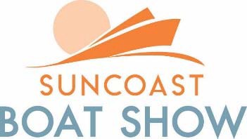

2024

ENVIRONMENTAL RULES AND REGULATIONS CAPTAINS AND CREWS

The Department of Environmental Regulation provides the following information. Please follow all regulations so that we may continue to produce this show every year. These regulations will be enforced. Please enter the show area at idle speed.

PLEASE PAY ATTENTION TO THE FOLLOWING:

- NO WAKE ZONE
- MANATEE AREA
- NO FUELING OF VESSELS
- NO SEWAGE DUMPING
- VESSEL SEWAGE PUMP OUT IS PROHIBITED
- NO CHEMICAL PRODUCTS FOR CLEANING VESSELS
- NO CONTAMINATED BILGE PUMPING
- NO PROPULSION ENGINE OPERATION
- NO REPAIR OR MAINTENANCE OF ENGINES ON SITE
- NO HULL CLEANING INVOLVING SCRAPING OR JET WASHING

BEST MANAGEMENT PRACTICES

Discharge of Sewage from Vessels (excludes "Gray water"):
Marine facility operators shall advise all tenants of the following: It is illegal to discharge sewage from vessels into the waters. Illegal discharge of sewage from vessels is subject to stiff fines and repercussions.

Waste Oil:
This includes waste engine oil, transmission fluid, hydraulic oil, and gear oil. Waste oil must be stored in non-leaking container clearly marked "waste oil" on an impermeable surface, and covered in a manner that will prevent rainwater from entering the container. Oil spills must be removed from the site by a permitted waste oil transporter and receipts retained for inspection.

New Oil:
This includes new engine oil, transmission fluid, hydraulic oil, and gear oil. These petroleum products must be kept in non-leaking containers on an impervious surface and covered in a manner that will prevent rainwater from entering the container. Leaking containers must be emptied promptly upon detection, either by transferring the product to a non-leaking container or by disposing of it in the "waste oil" container.

Anti-Freeze Engine Coolant:
Anti-freeze is considered a hazardous product and when drained from an engine, it must be stored in a clearly marked container on an impervious surface, under cover. It cannot be disposed of down a storm drain or sanitary sewer. It must be removed from the site by a permitted liquid waste transporter, and receipts must be retained for inspection. Care must be taken in handling these products and spills cleaned up promptly at the time detected

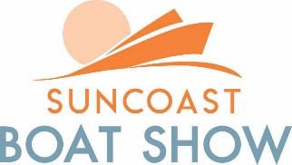

2024

Bilge Waste Water:
Bilge wastewater and "gray" water that is not contaminated by oil, fuel or other regulated containment's may be discharged onto surface waters or on land. Federal, state and local regulations prohibit the discharge of bilge wastewater and "gray" water that is contaminated by oil, fuel or other regulated containment's. Boat owners shall be liable for complying with these regulations. "Gray" water shall mean wastewater from galley operations (dishwashing) and from hand basins and showers.

Used Lead-Acid Batteries:
These must be stored on an impervious surface, under cover, and sent to or picked up by an approved recycler. Receipts must be retained for inspection.

Pressure Cleaning:
The use of high or low-pressure water cleaning equipment for the initial rinse-off of a vessel hauled from the water is acceptable. However, any accumulated algae, oyster or barnacle build-up must be properly collected and disposed of in the regular trash. The use of this equipment to remove bottom paint from hulls shall be restricted to an area with an impervious surface, where the wastewater shall be contained, collected and treated to remove paint solids to meet the sanitary sewer standards. If standards are not met, further treatment will be required prior to discharging to the sanitary sewers.

Washing by Hand Above Waterline:
Detergents and cleaning compounds used in washing boats shall be biodegradable. The waste water generated by washing boats by hand shall not be considered an "industrial waste" or "other waste" as defined in chapter 24.

Sanding Hull or Topsides with Power Tools:
Permitted facilities shall set and enforce their own rules in regard to the use of power sanding tools. However, the sanding dust generated by this activity must be swept up and disposed of with the regular trash and may not be intentionally discharged into a storm drain or onto surface waters.

Waste Gasoline:
Must be stored in a non-leaking container or impervious surface and covered to prevent rain water from entering the container. The container must be clearly labeled "waste gasoline" and the storage location must conform to local Fire Codes. Whenever, possible waste gasoline shall be filtered and used as fuel. Waste gasoline shall not be discharged to the ground, storm sewers, or to surface waters. Waste gasoline must be removed from the site by a waste transporter permitted to handle this waste product and receipts must be retained for inspection.

Waste Diesel, Kerosene, and Mineral Spirits:
These must be stored in non-leaking containers on a impervious surface, and covered to prevent rain water from entering the container. Each container must be clearly labeled with its contents. The storage locations shall conform to local Fire Codes. The disposal of these waste products must be by a waste transporter permitted to handle such wastes, and receipts must be retained for inspection. Waste petroleum products shall not be discharge to the ground, storm sewers or to the surface waters.

Grease:
Spilled or waste grease shall be collected and put into the waste oil container. Residues remaining on the ground may be absorbed with "spill-dry" or a similar product and disposed of with the regular trash.
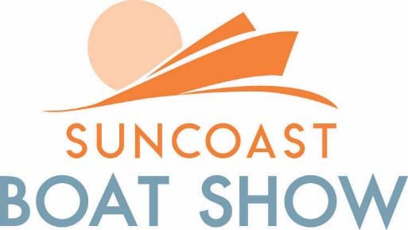

2024 BREAKDOWN INSTRUCTIONS

LAND AND BOOTH
After the Show closes to the public, those Exhibitors wishing to remove their display, may do so from 5:30p.m. - 8:00 p.m. Boats and/or equipment may be removed as well please call the Show office to coordinate your move.

IN-WATER BREAKDOWN:
If you wish to leave after the show Sunday evening April 21, 2024, please contact Nick Pantner in the Show Office so he may be able to assist you with your departure request. A Set-up Official will be monitoring VHF Channel 71 should you need to contact us.

